## **RESUME**

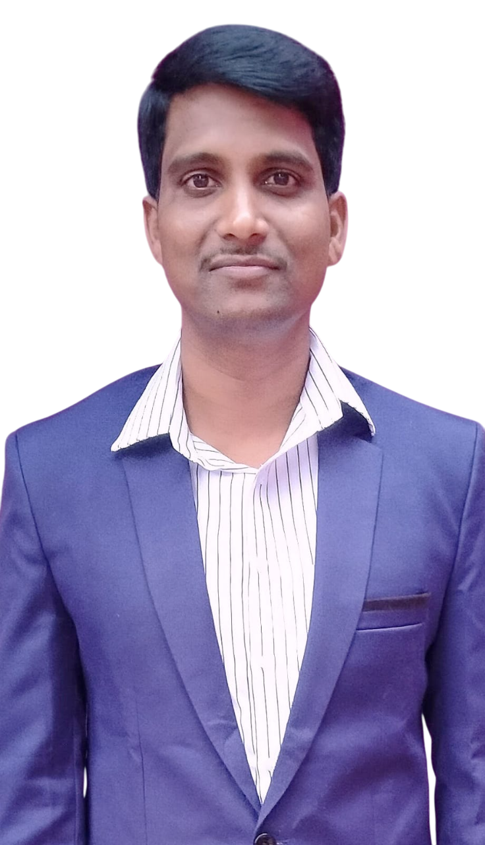

**Name: PUJAR**I  **ANJANEYULU**

**Email:**[anji.kld@gmail.com](mailto:anji.kld@gmail.com)

**Mobile: +91-9666502021**

**+91-7780367003**

## **Address for communication:**

## D.NO: 9D-113A Revenue colony

Kalyandurg (M), Anantapur (Dist)

Andhra Pradesh (S).

**Career Objective:**

To get an opportunity to work with an esteemed organization and become an asset to the organization by contributing meaningfully to its progress through a process of constant value and skill enhancement.

**Educational Qualifications:**

|  |  |  |  |
| --- | --- | --- | --- |
| **QULIFICATION** | **ACADIMIC YEAR** | **INSTITUTION** | **PERCENTAGE** |
| **Master of Technology(Computer Science & Engineering)** | 2016 | Intell Engineering College, Anantapur.**University of JNTU Anantapur** | 64% |
| **Bachelor of Technology**(**Computer**  **Science & Engineering**) | 2013 | Annamacharya Institute of Technology & Sciences (AITS),Rajampet. **University of JNTU Anantapur** | 63% |
| **Intermediate Public**  **Examination** | 2009 | **Govt. Jr. College**,  Kalyandurgam.  Board of Intermediate Examinations, Govt. of A.P. | 85% |
| **Secondary School Certificate Examination** | 2007 | **Govt. High School,** Kalyandurgam. | 75% |

**Others Qualification:**

* I qualified in **APSET 2020 ( Computer Science & Applications)**

**Computer Skills:**

* **Computer fundamentals:** Computer hardware& software, MS-Office.
* **Languages:** C, C++, Java, HTML, CSS, JavaScript, PHP, Python, SQL.
* **Subjects:** DBMS, OS, E-commerce&Web development etc.

**Other Skills:**

* Self-motivated and self-starter and extremely hard working.
* Positive Thinker and a Quick Learner.
* An excellent team player, approachable, and adaptable.

**Experience:**

* I have 6 years of teaching experience in computer science and applications.

**Personal Profile:**

Name **: PUJARI ANJANEYULU**

Father’s Name **:** P EKANTHAPPA

Date of Birth **:** 19-07-1992

Gender **:** Male

Nationality **:** Indian

Hobbies  **:** Watching Movies, Playing chess.

Languages Known **:** English and Telugu.

I hereby declare that all the above furnished information is true to the best of my

knowledge.

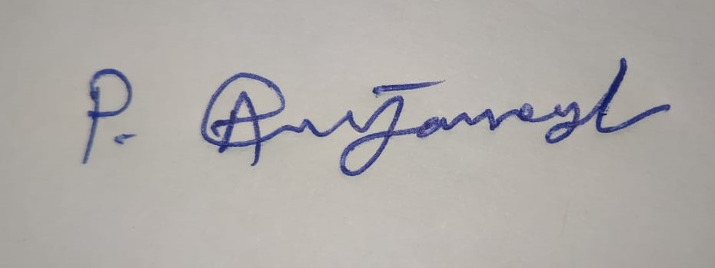

(P ANJANEYULU)